### Practical File

### of

### Source Code Management

### (22CS003)

#### Submitted in

#### partial fulfillment for the award of the degree of

## BACHELOR OF ENGINEERING

***in***

COMPUTER SCIENCE & ENGINEERING



**CHITKARA UNIVERSITY INSTITUTE OF ENGINEERING & TECHNOLOGY**

**CHITKARA UNIVERSITY**

**CHANDIGARH-PATIALA NATIONAL HIGHWAY**

**RAJPURA (PATIALA) PUNJAB-140401 (INDIA)**

##### **Submitted to: Submitted by:**

##### Faculty name: Dr Kalpna Guleria Student Name: Vaidehi Singh

##### Designation: Professor (Research) Roll No: 2310991234

##### Chitkara University, Punjab Sem: 2nd Batch:2023

##### Session: 2023-2024

**LIST OF PRACTICALS**

| **S.No.** | **Date** | **Practical** | **Page No.** | **Signature** |
| --- | --- | --- | --- | --- |
| 1. | 11-02-2024 | Introducing Version Control – Git client (CLI, GUI), Linux environment Emulation, Advantages of VCS, Installing git CLI and git GUI | 3-14 |  |
| 2. | 11-02-2024 | Setting up of the Github Account and linking Github account with gitbash | 15-20 |  |
| 3. | 11-02-2024 | Creating a repository, Adding files, checking status,  staged files/ untraced files and performing Commits | 21-23 |  |
| 4. | 11-02-2024 | Generating logs: Visualization of various git logs | 24-25 |  |
| 5. | 11-02-2024 | Git lifecycle description Git status, add, commit, stage – Life cycle of a file in Git managed in Repos. | 26 |  |
| 6. | 11-02-2024 | Git branching and Merging: Visualization of git Branch and HEAD, Git branches management, Create a new branch, Commit changes in the new branch, Explore commit in the new branch, Merging the branches | 27 |  |

**EXPERIMENT NO.1**

**AIM: Embracing Version Control with Git: CLI and GUI implementation in a Linux Environment.**

* **Introduction to Version Control Systems (VCS):**

Version Control Systems (VCS) are software tools that help manage changes to source code over time. They provide a systematic way to track modifications, enabling teams to collaborate efficiently on software development projects. With VCS, developers can keep track of every modification made to the codebase, revert to previous versions if needed, and collaborate seamlessly with team members.

VCS operates by creating a repository, which serves as a central database to store all project files and their revisions. Whenever a change is made to a file, the VCS records the modification along with relevant metadata such as the author, timestamp, and a brief description of the change. This enables developers to understand the evolution of the codebase and coordinate their efforts effectively.

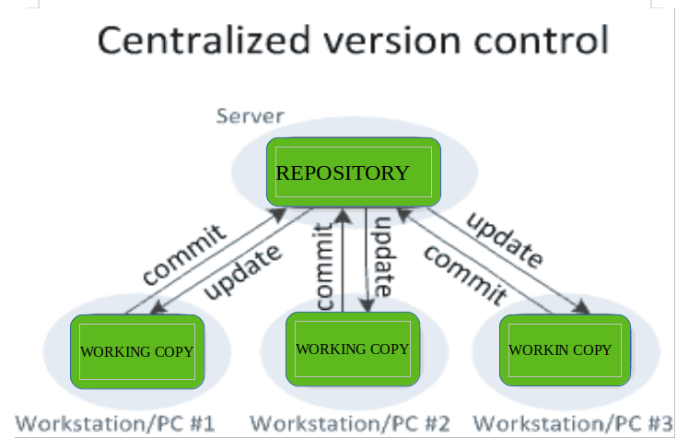

* **Advantages of Using Version Control Systems:**
* **Collaboration:**

VCS facilitates collaboration among team members by providing a centralized platform where developers can share code, review changes, and resolve conflicts. Multiple developers can work on the same codebase simultaneously without interfering with each other's work.

* **Tracking Changes:**

VCS keeps a detailed record of all changes made to the codebase, including additions, deletions, and modifications. This allows developers to track the evolution of the project over time and understand the rationale behind specific changes.

* **Managing Project History:**

VCS maintains a comprehensive history of the project, including all past revisions and their associated metadata. This historical record serves as a valuable resource for understanding past decisions, troubleshooting issues, and auditing the development process.

* **Branching and Merging:**

VCS supports branching, allowing developers to create separate lines of development for new features or experimental changes. Branches can be merged back into the main codebase once they are completed andtested, enabling a structured approach to feature development.

* **Backup and Disaster Recovery:**

VCS acts as a backup mechanism for the codebase, ensuring that data is not lost even in the event of hardware failures or accidental deletions. Developers can always revert to previous versions of the code in case of emergencies, minimizing the risk of data loss.

**In summary, version control systems are essential tools for modern software development, offering benefits such as collaboration, change tracking, project management, and disaster recovery. By leveraging VCS effectively, teams can streamline their development workflows, improve productivity, and deliver high-quality software products more efficiently.**

* **Overview of Git as a Distributed Version Control System (DVCS):**

Git is a distributed version control system designed to handle everything from small to very large projects with speed and efficiency. Unlike centralized version control systems (CVCS) where a single, central server stores all versions of the code and team members must communicate with this central server to access and manage files, Git allows every developer to have their own local repository, complete with a full history of commits. This decentralized approach provides several advantages, including faster access to project history, the ability to work offline, and greater resilience to server failures.

With Git, each developer maintains their own local repository, which contains the entire project history along with all branches and commits. Developers can work independently on their local repositories, making changes, creating branches, and experimenting with new features without impacting the work of others. When ready, changes can be synchronized with remote repositories, allowing for seamless collaboration with other team members.

* **Explanation of Key Git Concepts:**
* **Repositories:**

A Git repository, or repo, is a collection of files and directories associated with a specific project, along with the entire history of changes made to those files. Each repository can exist either locally on a developer's machine or remotely on a server (e.g., GitHub, GitLab). Repositories can be cloned, allowing developers to create local copies of remote repositories to work on.

* **Commits:**

A commit in Git represents a snapshot of the project at a specific point in time. It includes the changes made to the files since the last commit, along with metadata such as the author, timestamp, and a unique identifier(SHA-1hash). Commits are the building blocks of project history and provide a way to track changes over time.

* **Branches:**

A branch in Git is a lightweight movable pointer to a specific commit. Branches allow developers to work on multiple independent lines of development simultaneously. The main branch in Git is typically called "master" (or "main" in more recent conventions), and developers create new branches from this main branch to work on new features or bug fixes. Branches can be merged back into the main branch once the changes are complete and tested.

* **Merges:**

Merging is the process of combining the changes from one branch into another. When a feature branch is ready to be incorporated into the main branch, developers can merge the changes using Git's merge functionality. Git automatically identifies and resolves any conflicts that arise from overlapping changes between branches, allowing for a seamless integration process.

**By understanding these key concepts, developers can effectively use Git to manage their projects, collaborate with team members, and track changes over time, enabling a more streamlined and efficient development workflow.**

* **Introduction to Git Clients:**

Git clients are software tools that provide users with interfaces to interact with Git repositories. These clients come in two main flavors: command-line interface (CLI) and graphical user interface (GUI).

* **Command-Line Interface (CLI):**

CLI Git clients allow users to interact with Git through text-based commands entered in a terminal or command prompt.

They provide direct access to Git's full range of functionalities, enabling users to perform various operations such as cloning repositories, creating branches, committing changes, and merging branches.

Examples of CLI Git clients include the Git command-line tool itself, which is the official Git client, as well as other terminal-based Git clients like Magit (for Emacs users) and Tig (for terminal-based Git browsing).

* **Graphical User Interface (GUI):**

GUI Git clients offer a visual interface for interacting with Git repositories, typically featuring point-and-click operations instead of command-line commands.

They provide a more user-friendly experience for users who prefer visual representations of Git operations and project history.

GUI Git clients often include features like visual commit history graphs, drag-and-drop functionality for branching and merging, and built-in diff viewers for comparing file changes.

Examples of GUI Git clients include GitKraken, Sourcetree, GitHub Desktop, and Git Extensions.

* **Brief Comparison of CLI vs. GUI:**

**CLI Strengths:**

* **Flexibility:**

CLI Git clients provide access to the full range of Git functionalities, allowing users to execute complex commands and scripts efficiently.

* **Efficiency:**

Experienced users often find CLI Git clients faster for performing repetitive tasks once they become familiar with the commands.

* **Scriptability:**

CLI Git commands can be easily incorporated into scripts and automation workflows, making them suitable for integrating Git with other tools and processes.

**GUI Strengths:**

* **Ease of Use:**

GUI Git clients offer a more intuitive and visually appealing interface, making them accessible to users who are less comfortable with the command line.

* **Visual Representation:**

GUI clients provide visual representations of the repository's history, branches, and commits, making it easier for users to understand complex branching and merging scenarios.

* **Built-in Tools:**

GUI Git clients often include additional built-in tools for tasks like code reviews, issue tracking, and repository management, enhancing the overall development experience.

**Use Cases:**

* **CLI:**

Well-suited for experienced users who prefer efficiency and flexibility, as well as for integrating Git with automated workflows and scripts.

* **GUI:**

Ideal for beginners or users who prefer a more visual approach to Git operations, as well as for teams collaborating on projects where a graphical representation of the codebase is beneficial.

**In summary, both CLI and GUI Git clients offer unique strengths and are suitable for different use cases and user preferences. Developers can choose the client that best aligns with their workflow and level of expertise in Git.**

* **Linux Environment Emulation:**

Emulating a Linux environment involves creating a virtualized instance of a Linux-based operating system within another operating system environment. This can be achieved through native Linux installations or virtualization software such as VirtualBox or VMware.

* **Below is an overview of both approaches:**
  + **Native Linux Installation Process:**

This method involves installing Linux directly onto a physical machine, either as the primary operating system or as a dual-boot alongside another operating system like Windows or macOS.

* + **Advantages:**

Performance: Running Linux natively typically results in better performance compared to virtualized environments.

* + - **Full Access:** Users have direct access to hardware resources, allowing for optimal utilization and performance tuning.
    - **No Overhead:** There is no overhead from virtualization software, resulting in a more streamlined experience.
  + **Considerations:**
    - **Hardware Compatibility:**

Ensure that the hardware is compatible with the chosen Linux distribution to avoid driver issues.

* + - **Disk Partitioning:**

Dual-boot setups require careful disk partitioning to avoid data loss and ensure proper boot configuration.

* + - **Risk of System Modification:**

Installing Linux natively involves modifying system settings and partitions, which carries a risk of data loss or system instability if not done correctly.

* **Virtualization using Tools like VirtualBox or VMware:**
  + - **Process:**

Virtualization software such as VirtualBox or VMware allows users to create virtual machines (VMs) that run guest operating systems within a host operating system environment.

* **Advantages:**
  + - **Isolation:**

Virtual machines provide a sandboxed environment, isolating the guest operating system from the host system.

* + - **Portability:**

Virtual machines can be easily moved and copied between different host systems, making it convenient for testing and development.

* + - **Snapshotting:** Virtualization software often supports snapshot functionality, allowing users to save and restore the state of a virtual machine at different points in time.
* **Considerations:**
  + - **Resource Overhead:**

Virtualization imposes overhead in terms of CPU, memory, and disk usage, which can impact performance compared to native installations.

* + - **Hardware Support:**

Some advanced hardware features may not be fully supported in virtualized environments, limiting their usability for certain use cases.

* + - **Licensing:**

Users may need to consider licensing implications, as some software licenses may have restrictions on virtualized deployments.

**In summary, emulating a Linux environment can be achieved through either a native installation or virtualization using tools like VirtualBox or VMware. Each approach has its advantages and considerations, and the choice depends on factors such as performance requirements, hardware compatibility, and portability needs.**

* **Advantages of Using Git via Command Line Interface (CLI):**
  + - **Flexibility:**

The command-line interface (CLI) provides direct access to Git's full range of functionalities, allowing users to execute complex commands and customize their workflow according to specific needs. Users have fine-grained control over Git operations, including branching, merging, rebasing, and more.

* + - **Efficiency:**

Experienced users often find CLI Git clients faster for performing repetitive tasks once they become familiar with the commands. With the CLI, users can navigate through repositories, stage changes, commit revisions, and push/pull updates with minimal keystrokes, enhancing overall productivity.

* + - **Scriptability:**

CLI Git commands can be easily incorporated into scripts and automation workflows, making them suitable for integrating Git with other tools and processes. This enables users to automate common tasks, such as generating release notes, deploying changes, or performing code reviews,streamlining development workflows and increasing efficiency.

* **Advantages of Using Git through a Graphical User Interface (GUI):**
  + - **Ease of Use:**

Git GUI tools provide a user-friendly interface with intuitive menus, buttons, and visual elements, making it easier for users who are less comfortable with the command line to interact with Git repositories.

* + - **Visual Representation of Project History:**

GUI tools often include visualizations such as commit graphs, branch timelines, and file change history, which help users understand the evolution of the project and track changes more effectively.

* + - **Simplified Workflows:**

GUI tools streamline common Git operations by providing guided workflows and automated features. Users can perform tasks like branching, merging, and resolving conflicts with minimal manual intervention, reducing the learning curve and improving productivity

* **Introduction to Popular Git GUI Tools:**
  + - **GitKraken:**

GitKraken is a popular cross-platform Git GUI tool known for its sleek and intuitive interface.

It offers features such as a visual commit graph, drag-and-drop branching, built-in merge conflict resolution, and integrations with popular Git hosting services like GitHub, GitLab, and Bitbucket.

GitKraken also provides team collaboration features, such as built-in code reviews and real-time collaboration via GitKraken Boards.

* + - **Sourcetree:**

Sourcetree is a free Git GUI client developed by Atlassian, known for its simplicity and ease of use.

It offers a visual interface for managing Git repositories, including features like visual commit history, branch management, and Git flow support.

Sourcetree integrates seamlessly with Atlassian's other development tools, such as Bitbucket and Jira, providing a comprehensive solution for software development teams.

* + - **GitHub Desktop:**

GitHub Desktop is an official Git GUI client developed by GitHub, designed to provide a seamless experience for users interacting with GitHub repositories.

It offers a simplified interface for common Git operations, including branching, committing, and syncing changes with GitHub.

GitHub Desktop integrates tightly with GitHub, allowing users to clone repositories, create pull requests, and manage issues directly from the desktop application.

These Git GUI tools cater to a wide range of users, from beginners to experienced developers, by offering intuitive interfaces, powerful features, and seamless integrations with popular Git hosting platforms. Whether users prefer simplicity, visualizations, or integration with specific development workflows, there is a Git GUI tool available to meet their needs.

* **Installing Git CLI and Git GUI:**
* **Installing Git CLI:**
  + - **Windows:**

Download the Git for Windows installer from the official website and follow the installation instructions. Ensure that Git is added to the system PATH during installation.

* + - **macOS:**

Install Git using Homebrew by running brew install git in the terminal.

* + - **Linux:**

Use the package manager of your Linux distribution (e.g., apt for Ubuntu, yum for CentOS) to install Git.

* + - **Benefits of Git CLI:**

Git CLI offers efficiency and flexibility, allowing users to perform a wide range of Git operations through command-line commands.

* **Installing Git GUI:**

GitHub Desktop: Download and install GitHub Desktop from the GitHub website. Follow the setup wizard to configure the application.

* Visit directly on git book page by <https://git-scm.com/book/en/v2>

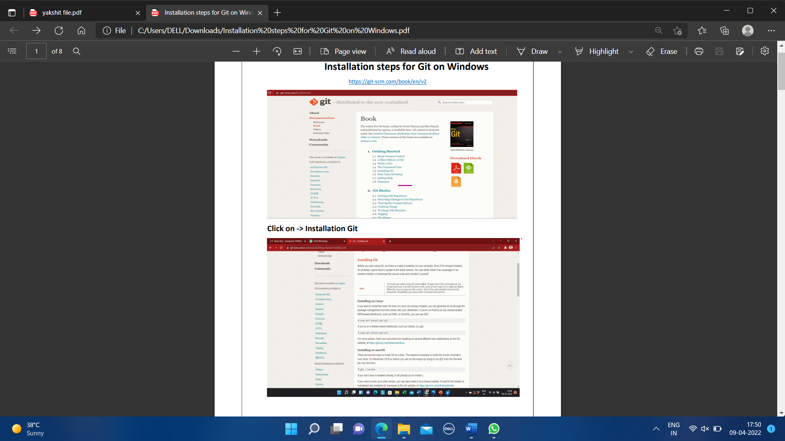

* Then click on Installation Git and click on whatever system you want, available are three- Windows, Apple and Linux.

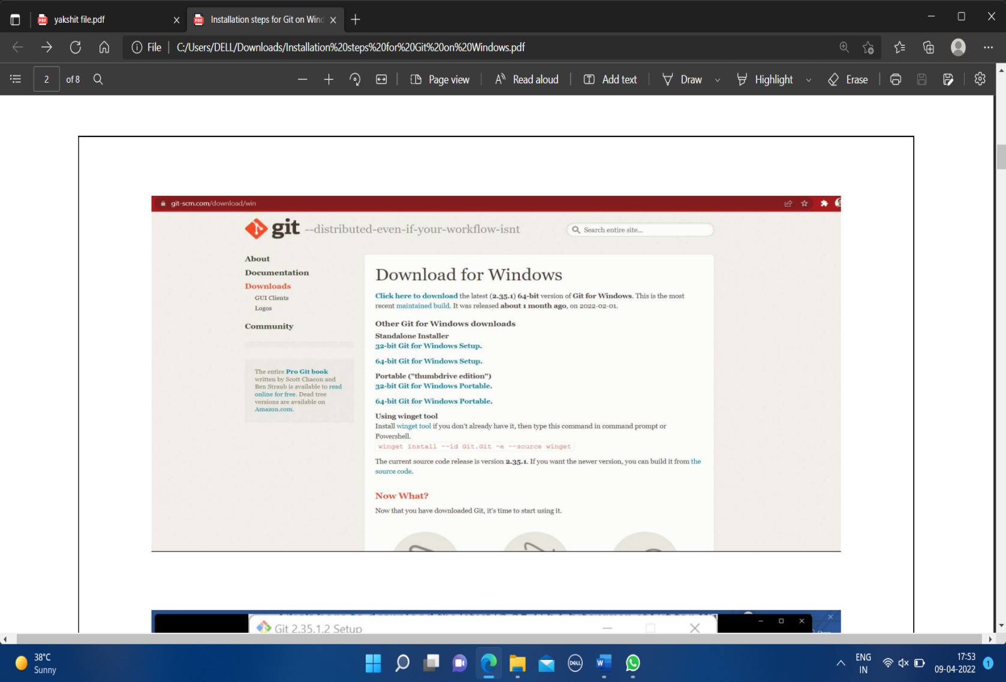

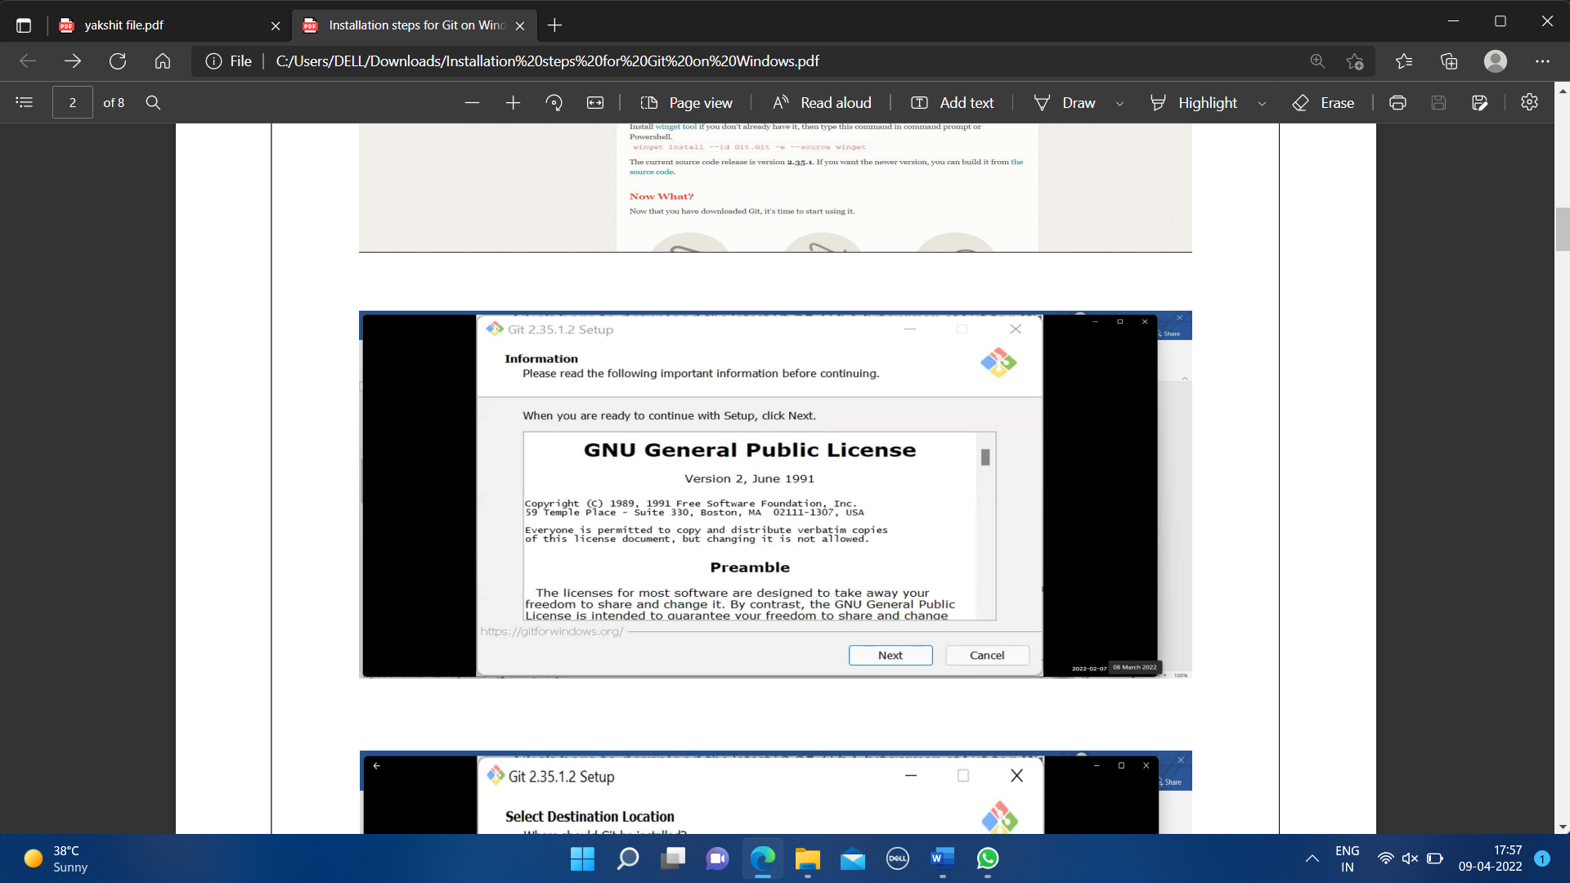

* After some more simple and easy settings and choosing your favorable environment and doing some SSH settings, it finally starts exporting the files in system and completes the Git hub wizard.

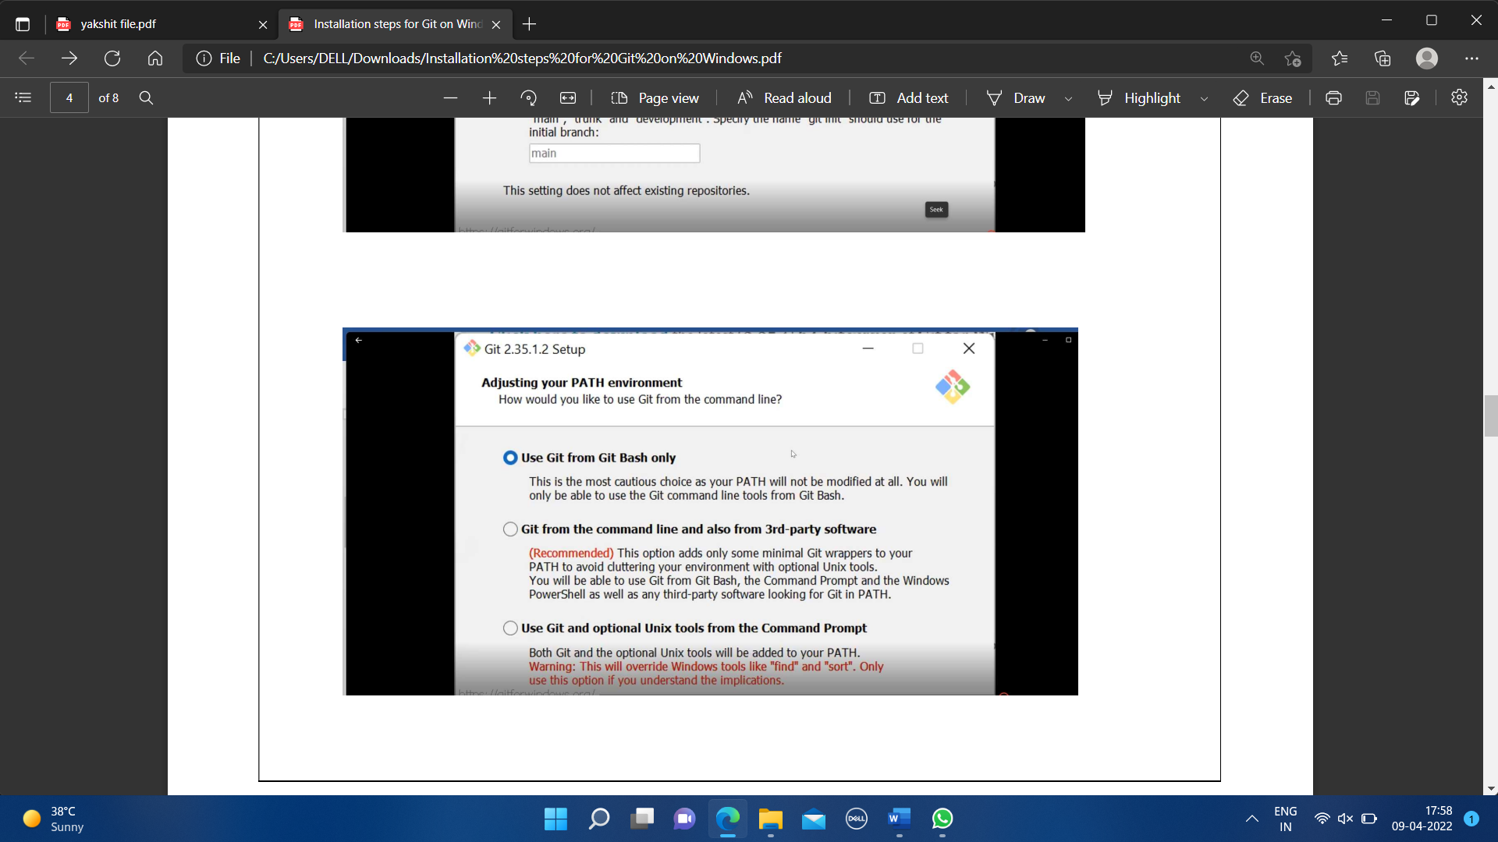

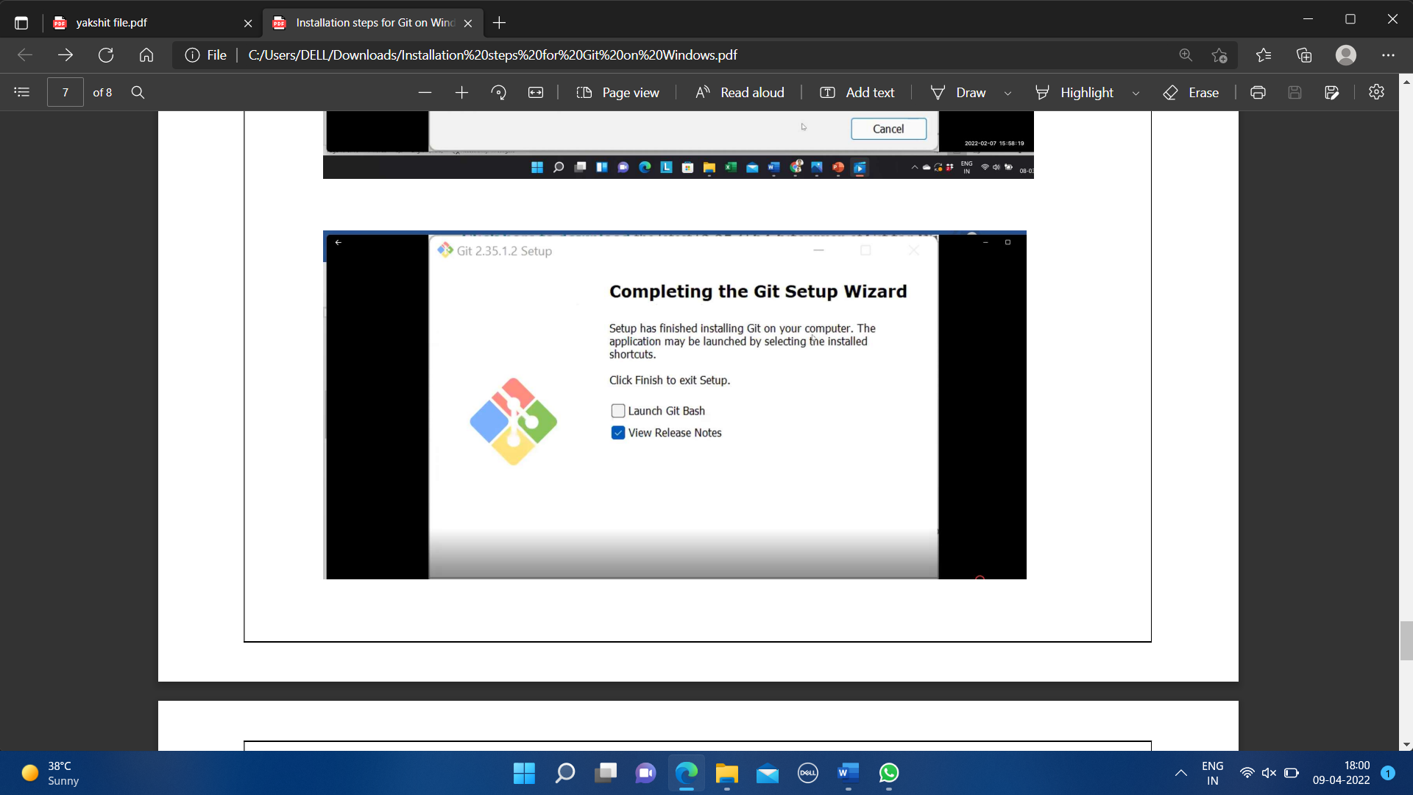

* Git bash got installed in system and seemed and opened on clicking seems of like:

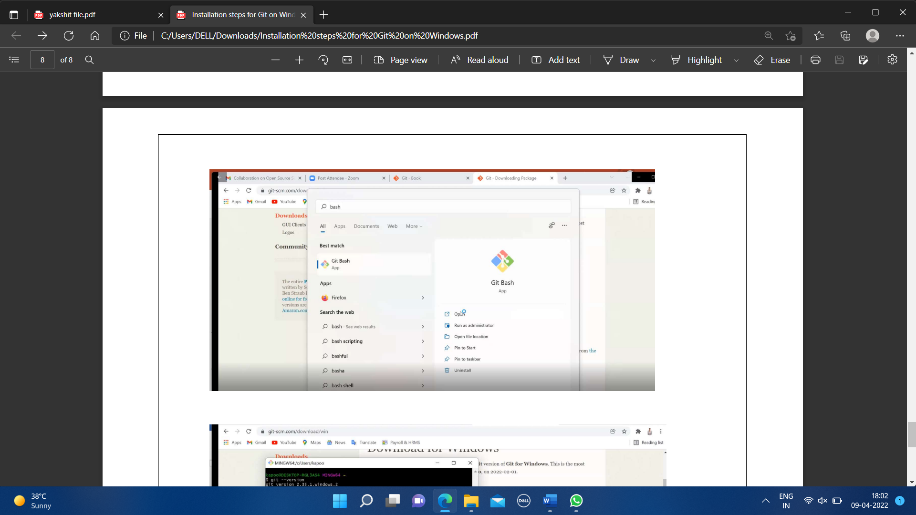

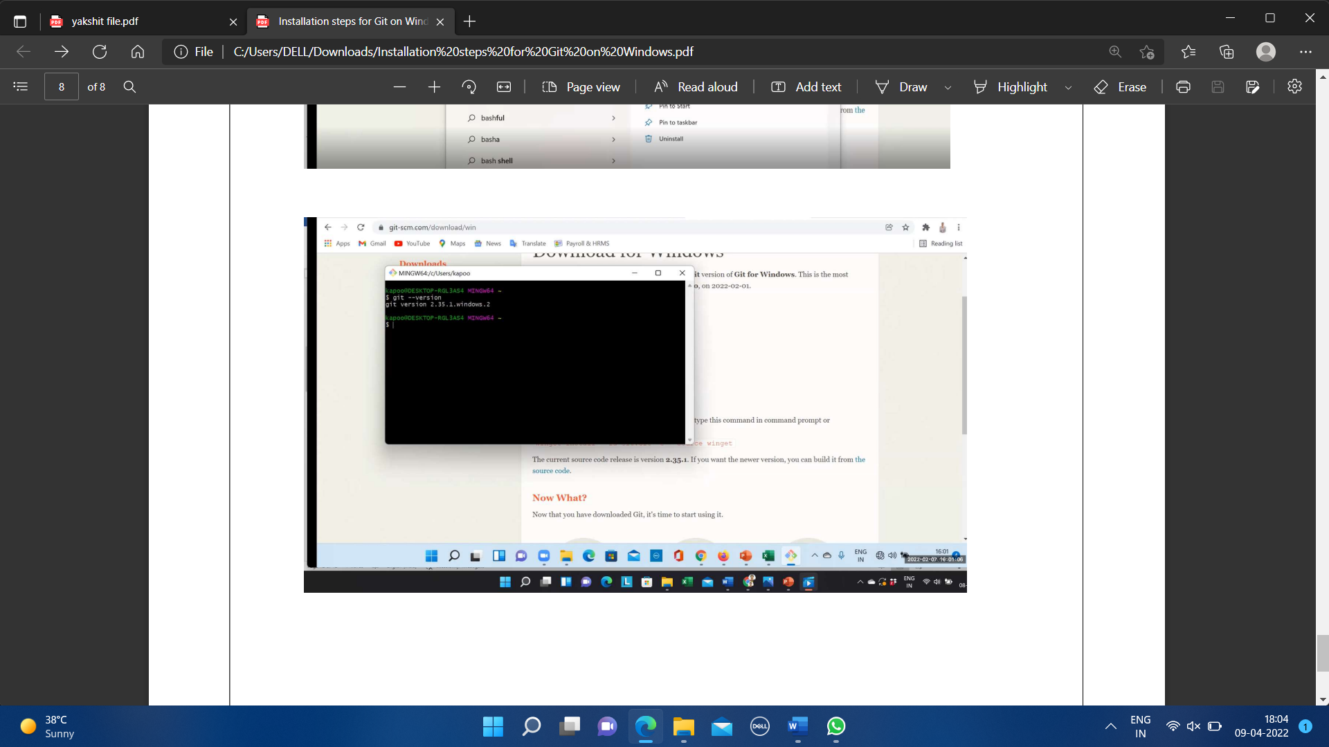

* You can also check the version of installed software by checking git version.

**EXPERIMENT NO.2**

**AIM:** **Setting up of the Github Account and linking Github account with gitbash**

* **What is Github?**

GitHub is a web-based platform used for version control and collaboration on software development projects. It allows developers to host their code repositories, track changes to their codebase over time, and collaborate with other developers through features like pull requests, code reviews, and issue tracking.

* **Key features of GitHub include:**
* **Repositories:**

Users can create repositories to store their code and related files. These repositories can be public, allowing anyone to view and contribute to them, or private, restricting access to authorized users.

* **Version Control:**

GitHub utilizes Git, a distributed version control system, to track changes to files within a repository. Developers can create branches to work on features or fixes independently and merge their changes back into the main branch when ready.

* **Collaboration Tools:**

GitHub provides features for collaboration such as pull requests, which allow developers to propose changes and request feedback from their peers. Code reviews can be conducted within pull requests to ensure code quality and maintain standards.

* **Issue Tracking:**

Users can create and manage issues to track bugs, feature requests, and other tasks related to a project. Issues can be assigned to specific users, labeled, and organized into milestones to help manage the development process.

* **Wikis and Documentation:**

GitHub allows users to create wikis and documentation pages for their projects, providing a centralized location for information about the project's structure, installation instructions, and usage guidelines.

* **Integration with Third-Party Services:**

GitHub integrates with various third-party services and tools, such as continuous integration (CI) systems, project management platforms, and code analysis tools, to streamline the development workflow.

Overall, GitHub has become a central hub for collaboration and community-driven development, particularly within the open-source software community, but also in many private and enterprise settings.

GitHub is a comprehensive platform for software development, fostering collaboration, transparency, and innovation within the developer community. Whether you're working on open-source projects or proprietary software, GitHub provides the tools you need to build, manage, and collaborate on your code effectively.

* **Where is Github used?**

GitHub is used in various contexts across different industries and by different types of users. Here are some common scenarios where GitHub is used:

* **Software Development:**

GitHub is primarily used for software development, both in the open-source and commercial sectors. Developers use it to host their code repositories, collaborate on projects, track issues, and manage software releases.

* **Open Source Projects:**

GitHub is a central hub for open-source projects. Many open-source communities and projects use GitHub to host their code, manage contributions from volunteers, and facilitate collaboration among developers worldwide.

* **Enterprise Development:**

Many organizations, including large enterprises, use GitHub for their internal software development projects. GitHub's collaboration features, version control capabilities, and integrations with other development tools make it a popular choice for teams working on proprietary software.

* **Education:**

GitHub is increasingly used in educational settings, such as universities and coding bootcamps, to teach version control, collaboration, and software development best practices. Students and instructors use GitHub to share code, collaborate on assignments, and track progress.

* **Research:**

Researchers and academic institutions use GitHub to share code and data related to scientific research. GitHub provides a platform for collaboration among researchers, enabling them to work together on projects, share findings, and reproduce experiments.

* **Documentation and Knowledge Sharing:**

GitHub is used for documenting projects, APIs, libraries, and software frameworks. Developers use wikis, README files, and project documentation features to provide information about their codebases, installation instructions, usage guidelines, and best practices.

* **DevOps and Continuous Integration/Continuous Deployment (CI/CD):**

GitHub integrates with CI/CD tools and services, allowing developers to automate testing, building, and deploying their applications. This is particularly useful in DevOps workflows, where automation is key to accelerating software delivery and ensuring code quality.

* **Community Engagement and Networking:**

GitHub provides a platform for developers to showcase their work, build a portfolio, and connect with other developers and potential collaborators. Developers can follow projects, contribute to discussions, and discover new projects based on their interests.

Overall, GitHub's versatility and collaborative features make it a widely adopted platform across various industries and use cases, empowering developers to build better software together.

* **Creating a GitHub Account:**
* **Head to GitHub:** Visit <https://github.com/> and click "Sign up" to start the registration process.
* **Fill in your details:** Enter your username, email address, and a strong password. Choose a username that reflects your persona or work.
* **Verify your email:** Check your email inbox for a verification message from GitHub and click the link to confirm your account.

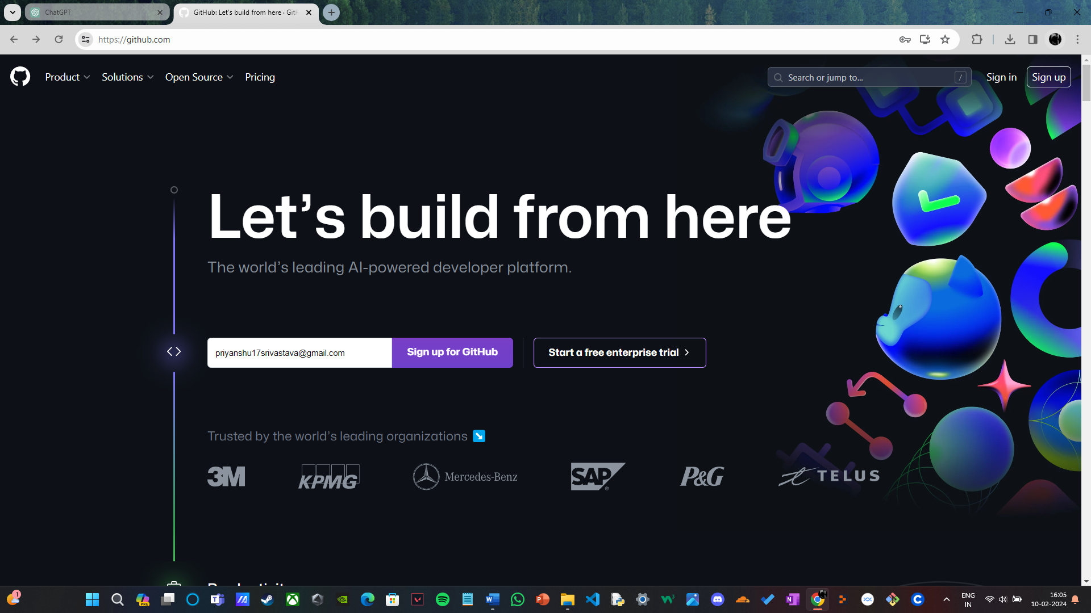

* **Installing Git and Git Bash:**
* **Download Git:** Go to <https://git-scm.com/downloads> and download the appropriate installer for your operating system.
* **Install Git:** Follow the installation instructions, making sure to select the option to "Use Git from the Windows command line" (if applicable).
* **Run Git Bash:** Open the Start menu, search for "Git Bash," and right-click on it to select "Run as administrator." This ensures you have the necessary permissions for Git operations.

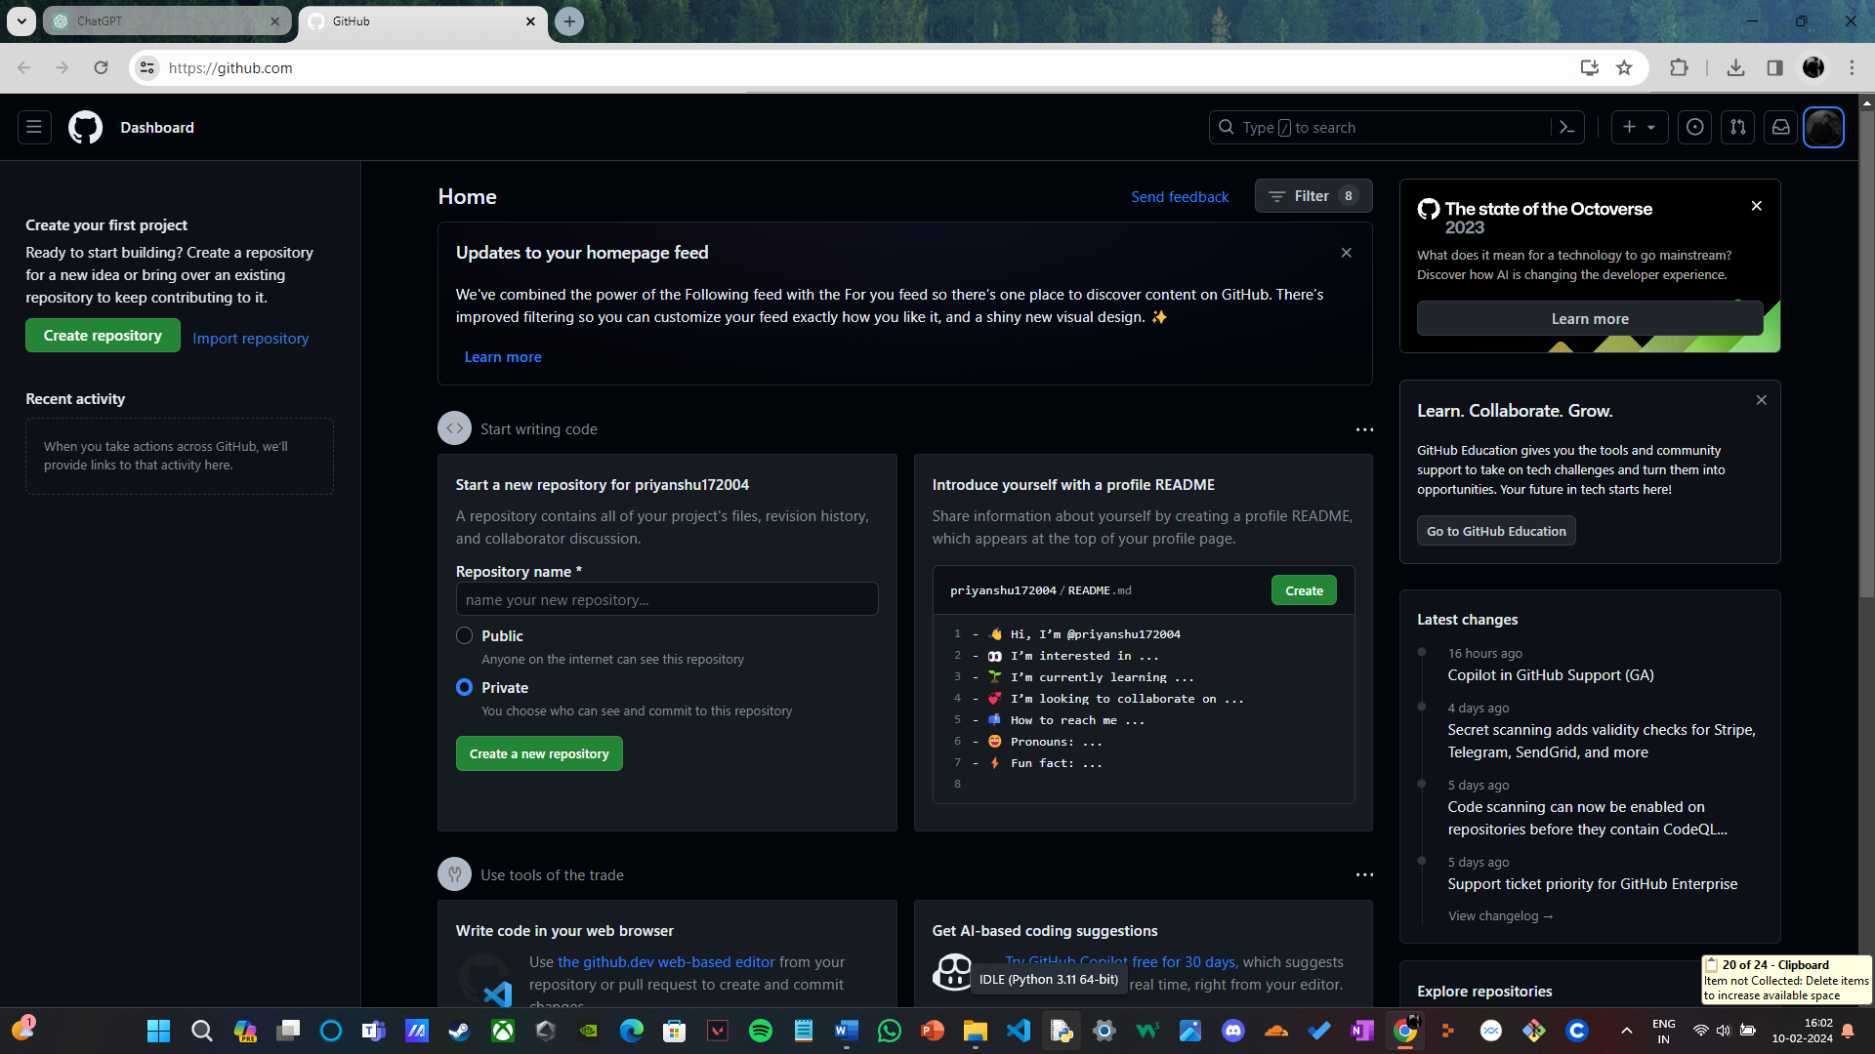

* **Configuring Git:**
* **Set your username and email:** In Git Bash, type these commands, replacing <username> and <email> with your actual information:
* **Verify configuration:** Run **git config --list** to view your Git configuration and confirm the username and email are correct.
* **Linking GitHub with Git Bash:**

* **Username:**

git config --global user.name “username in github”

* **Email:**

git config --global user.email “your email in github”

* **Check Username & Email:**

git config --global user.name

git config –global user.email

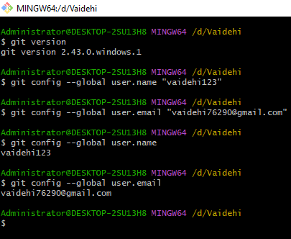

* **Clone or create a repository:** In Git Bash, navigate to your desired local directory and use the **git clone** command to clone a repository from GitHub. Replace **<username>** and **<repository>** with your actual information and paste the personal access token where prompted for password:

Alternatively, you can create a new repository directly in Git Bash using **git init** and then push it to GitHub.

* **Additional Tips:**
* **Consider using a secure password manager:** to store your personal access token or SSH key passphrase.
* **Regularly update your Git and Git Bash:** Check for updates to ensure you have the latest security patches and features.
* **Explore Git commands:** Learn about common Git commands like **git add, git commit, git push,** and **git pull** to manage your code effectively.

**EXPERIMENT NO.3**

**AIM:** **Creating a repository, Adding files, checking status, staged files/ untraced files and performing Commits**

* **Creating a Repository:**

Open your terminal or command prompt.

Navigate to the directory where you want to create your repository using the cd command.

**Use the following command to create a new repository:**

git init <repository_name>

Replace <repository_name> with the name you want to give to your repository.

* **Adding Files:**

Create or add the files you want to include in your repository in the directory where you initialized Git.

**Use the following command to add files to the staging area:**

git add <file1> <file2> ...

Replace <file1>, <file2>, etc., with the names of the files you want to add. You can also use . to add all files in the current directory.

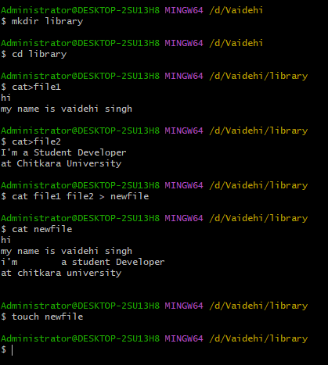

* **Checking Status:**

**To check the status of your files, use the following command:**

<git status>

This will display information about which files are modified, staged, or untracked.

Staged Files/Untracked Files:

Staged files are those that have been added to the staging area and are ready to be committed. Untracked files are those that Git is not currently tracking.

Use git add <file> to stage new or modified files.

Use git rm --cached <file> to unstage files from the staging area.

Use git rm <file> to remove files from both the working directory and the staging area.

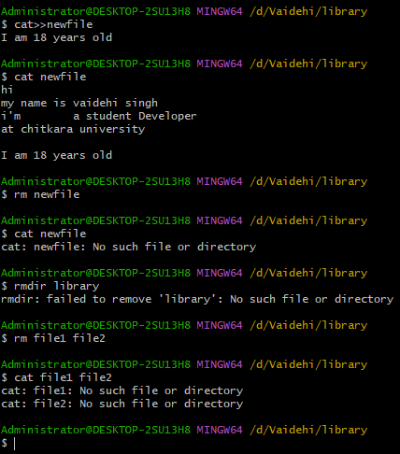

* **Performing Commits:**

**Once you've added the files you want to commit to the staging area, you can commit them using the following command:**

<git commit -m "Commit message">

Replace "Commit message" with a descriptive message summarizing the changes you made in this commit.

After committing, your changes will be saved to the repository.

By following these steps, you'll be able to create a repository, add files, check their status, manage staged and untracked files, and perform commits using Git.

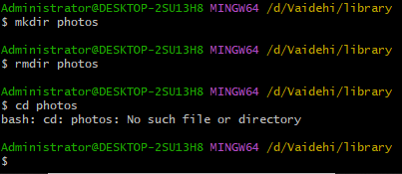

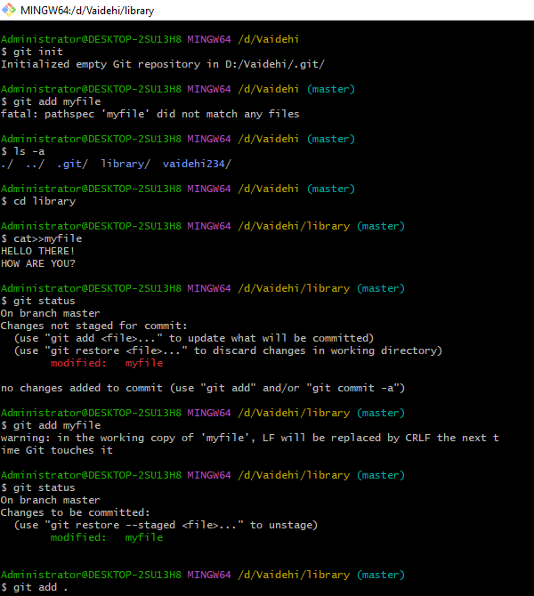

**EXPERIMENT NO.4**

**AIM:** **Generating logs: Visualization of various git logs**

**What are Git Logs?**

Git logs provide a record of the commit history in a Git repository. They display information about past commits, including the commit message, author, timestamp, and unique commit identifier (SHA-1 hash). Git logs are useful for understanding the history of changes in a project and for tracking the evolution of code over time.

**Why do we need logs?**

Git log is a utility tool to review and read a history of everything that happens to a repository. Anything we change at what time, by which log, everything is getting recorded in git logs.

You can use command **git log** to access logs (every change you make with time and date).

* **git log -p -1:** Shows files that are commited previously along with the content in it.
* **git log --pretty=oneline:** Shows all the commits made in short along with encrypted codes.

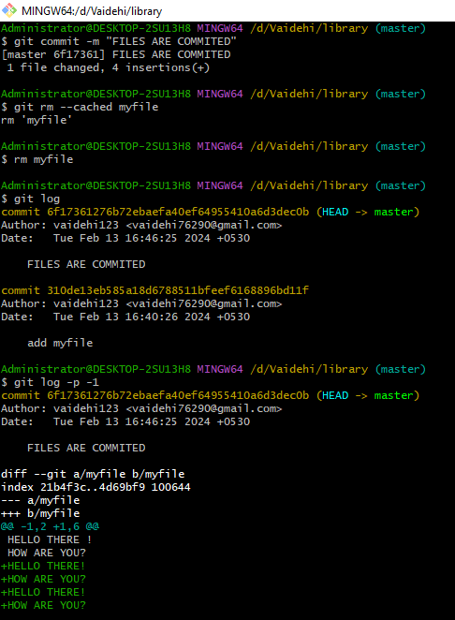

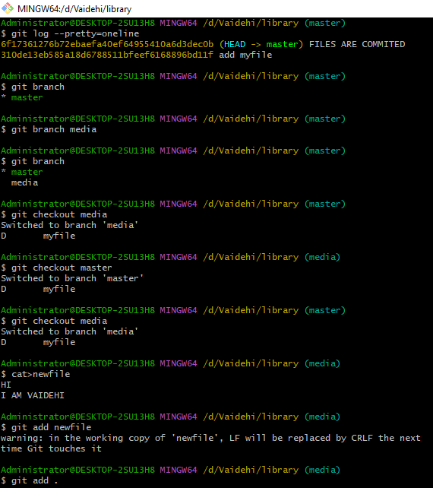

**EXPERIMENT NO.5**

**AIM: Git branching and Merging: Visualization of git Branch and HEAD, Git branches management, Create a new branch, Commit changes in the new branch, Explore commit in the new branch, Merging the branches**

How to create branches?

The main purpose of branching is to isolate the workspace from branch-master on different branch. The main branch in which we are working is master branch. you can use the “git branch” command with the branch name and the commit SHA for the new branch.

Git branching allows for parallel development, isolating changes, and experimentation.

You can create, switch between, and manage branches using Git commands.

Commits made in a branch are isolated to that branch until merged.

Merging combines changes from one branch into another.

Visualizing branches and commits helps understand the repository's history and development flow.

By understanding Git branching and merging concepts, you can effectively manage your project's development workflow and collaborate with others.



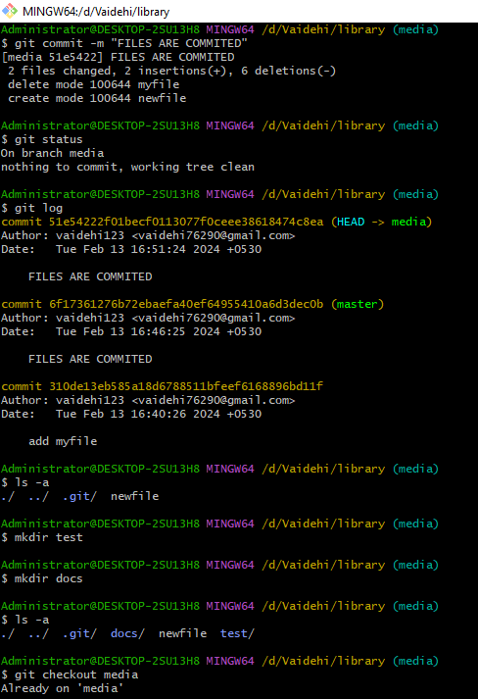

**EXPERIMENT NO.6**

**AIM: Git lifecycle description Git status, add, commit, stage – Life cycle of a file in Git managed in Repository**

The lifecycle of a Git repository involves various stages in the typical workflow of creating, modifying, and sharing code. Below is a detailed description of each stage in the Git lifecycle:

**Initialization:**

The process starts with creating a new Git repository or initializing Git in an existing directory. This is done using the git init command.

Alternatively, you can clone an existing repository from a remote location using git clone.

**Working Directory:**

This is where you do your work: creating, modifying, and deleting files.

Files in this directory are in one of the following states: untracked, modified, or staged.

**Staging Area (Index):**

Files in this area are queued up to be included in the next commit.

This allows you to selectively choose which changes you want to include in the next commit.

You stage changes using the git add command.

**Local Repository:**

Once you're satisfied with the changes staged in the index, you commit them to the local repository.

A commit creates a snapshot of your changes and adds a commit message describing the changes.

Use git commit to commit staged changes to the local repository.

**Branches:**

Git allows for branching, where you can diverge from the main line of development and work on new features or fixes independently.

Creating a new branch can be done using git branch [branch-name].

Switching branches is done with git checkout [branch-name] or git switch [branch-name].

Merging branches brings changes from one branch into another. This is done with git merge [branch-name].

**Remote Repository:**

Git enables collaboration by allowing repositories to be hosted remotely.

Common remote hosting services include GitHub, GitLab, and Bitbucket.

You can push your local changes to a remote repository using git push.

To fetch changes from a remote repository, you use git fetch.

To incorporate changes from a remote repository into your local branch, you use git pull.

**Conflict Resolution:**

When merging branches or pulling changes from a remote repository, conflicts may arise if there are conflicting changes.

Git marks these conflicts in the affected files, and you need to manually resolve them.

After resolving conflicts, you need to stage the resolved files and commit the changes.

**Version History:**

Git maintains a complete history of all commits made to the repository.

You can view the commit history using git log.

Each commit has a unique identifier (SHA-1 hash), author, timestamp, and commit message.

**Reverting and Resetting:**

If you need to undo changes, Git provides several options.

git revert creates a new commit that undoes a previous commit.

git reset can be used to reset the current branch to a previous state, either preserving or discarding changes.

Exercise caution with resetting, as it can alter the repository history.

**Tagging:**

Git allows you to mark specific commits with tags to denote important points in the history, such as releases or milestones.

Tags can be annotated (with a message) or lightweight (just a name pointing to a commit).

Use git tag [tag-name] to create a lightweight tag and git tag -a [tag-name] for an annotated tag.

This lifecycle illustrates the typical flow of working with Git, from initialization to collaboration and version control. Understanding these stages is crucial for effectively managing your codebase with Git.

**SUMMARY:**

**Here's a concise summary of the Git lifecycle:**

* Initialization: Start a new Git repository or initialize Git in an existing directory with git init.
* Working Directory: Create, modify, and delete files in your project directory.
* Staging Area (Index): Selectively stage changes for the next commit using git add.
* Local Repository: Commit staged changes to the local repository with git commit.
* Branches: Create, switch, merge, and delete branches to work on different features or experiments.
* Remote Repository: Connect your local repository to a remote repository, push changes, fetch updates, and pull changes from the remote.
* Conflict Resolution: Resolve conflicts that occur during merges or pulls by manually editing files, staging the changes, and committing.
* Version History: View the history of commits using git log, each identified by a unique SHA-1 hash.
* Reverting and Resetting: Undo changes with git revert or reset the repository to a previous state with git reset.
* Tagging: Mark specific commits with tags to denote important points in the history, like releases, using git tag.

Understanding and following this lifecycle enables effective version control and collaboration in software development projects using Git.